**Strength Measurement Toys for Children**

**Invention Disclosure to be sent to Columbia University for Patent Considerations**

**Sunil K. Agrawal, PhD1, Jesus Antonio Prado De La Mora1, Rosemarie C. Murray1, Danielle M. Stramel1, Haohan Zhang1, Andy Gordon2**

1Department of Mechanical Engineering, ROAR Laboratory, Columbia University, New York, NY 10027

1Department of Movement Sciences, Teachers’, Columbia University, New York, NY 10027

Strength capabilities of children are essential information to incorporate into the design of products that are intended for children to reduce or eliminate the risk such products might pose to a child (e.g., breaking, collapsing, etc.). Strength data for preschoolers are limited and similar data for toddlers and infants are almost non-existent. Collecting strength data for young children, especially children under three years old, is challenging. Traditional methods to collect maximum muscle strength on demand are not appropriate for young children who often fail to follow directions and might be difficult to motivate. For this reason, new measurement methods in a play or nursery environment, where a child is likely to exert maximum strength naturally, will need to be developed.

Here, we present a series of designs to be included in portable test kits with transducers that are embedded within the toy/play-board to allow for measurement of forces in children during a wide variety of tasks involving their fingers, hands, feet, body, teeth in activities such as pinch, pull, push, bite, etc. These test kits are designed to be adaptable for different age groups and task activities, where the design parameters can be changed as per the needs of the children. The toys either use displacement transducers which can be calibrated periodically with force-torque sensors or piezoresistive force sensors. The transducers wirelessly connect to data acquisition software and a display providing feedback to motivate the child in order to perform at their maximum level. The sensors will be used to idetify maximum force, force direction, time to achieve maximum force, the duration of the peak, and time to fatigue when force is sustained.

**Push-pull device for hand, pinch, and fingers:** A schematic of a general push/pull device is shown in Fig. 1 (left panel) along with different handles for the hand, pinch, and fingers. The base mount can be attached to a fixed surface. Once force is exerted on the handle by the child, the spring will be displaced and will be measured by a potentiometer, with a change in voltage. This displacement will be calibrated by a removable force/torque load cell unit, as shown in Fig. 1 (right panel), periodically. The spring displacement (voltage) will be recorded by a real-time data acquisition system and linked to an age-appropriate graphic/audio/video user interface to engage the child to apply their maximum strength.

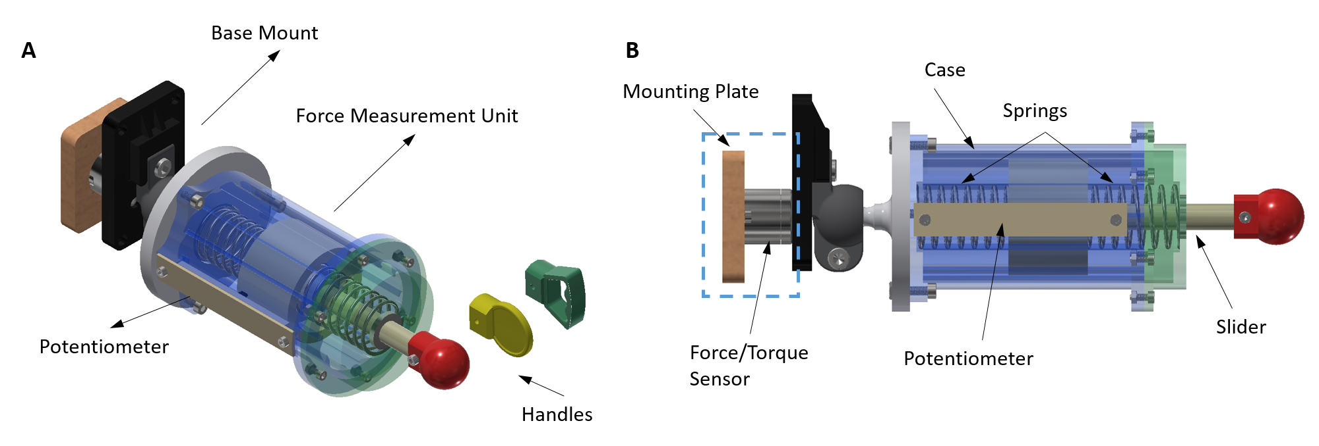

**Fig. 1:** (A) Schematic of a general push/pull device with different handles to be used with hand, pinch, and fingers. The base mount can be attached to a fixed frame. The frames will be positioned in the horizontal, vertical, or diagonal orientations based on the task. Once force is exerted on a handle by the child, the spring will be displaced and is recorded in real-time by a potentiometer through a change in voltage. This will be wirelessly sent to a computer tablet with a graphical user interface for audio/video/graphics.

While the basic sensing mechanism will stay the same across the push and pull tasks, the force applied by a child in each task is expected to be different. For example, a pull with fingers will yield a much smaller force than pull with the hand. To accommodate these differences, the choice of the spring stiffness, dimension of the spring, the load cell to calibrate the spring will be task specific. The interface handles will be scaled up to meet the age and strength level of the child.

**Hand Grip and Foot Device:** A schematic of a hand grip/foot device that consists of a rigid member supported at the two ends by springs (Fig. 2 left panel). The displacements of the two springs are measured by potentiometers, which are calibrated by a removable load cell periodically. The spring displacements are recorded by a data acquisition system and linked to a real-time age-appropriate graphic/audio/video user interface to engage the child to apply their maximum strength. The choice of the spring stiffness, dimension of the springs, the load cells to calibrate the springs will be task specific. The design will be scaled up to meet the age of the child. Fig. 2, Bottom and Right panels, show the schematic of the device used to measure foot strength and grip strength, respectively.



**Fig. 2:**  (A) Schematic of a hand grip/foot device that consists of a rigid member supported at the two ends by springs. The displacements of the two springs are measured by potentiometers. The design allows a removable load cell to calibrate the force-displacement characteristics of the spring, periodically. (B) The schematics to use the device to measure Feet pull/push and Grip squeeze forces.

**Twist Device**: A schematic of a twist device is shown in Fig. 3 left panel which consists of a rigid rod, with bearings at the two ends, held by springs at the two ends. The twist device is actuated with different handles. The rotation of the rod is measured by a potentiometer. The design allows a removable load cell to be placed at the end of the rod to calibrate the torque-angular displacement characteristics of the spring, periodically. The spring displacements are recorded by a data acquisition system and linked to a real-time age-appropriate graphic/audio/video user interface to engage the child to apply their maximum strength. The entire designs will be scaled up to meet the age of the child.

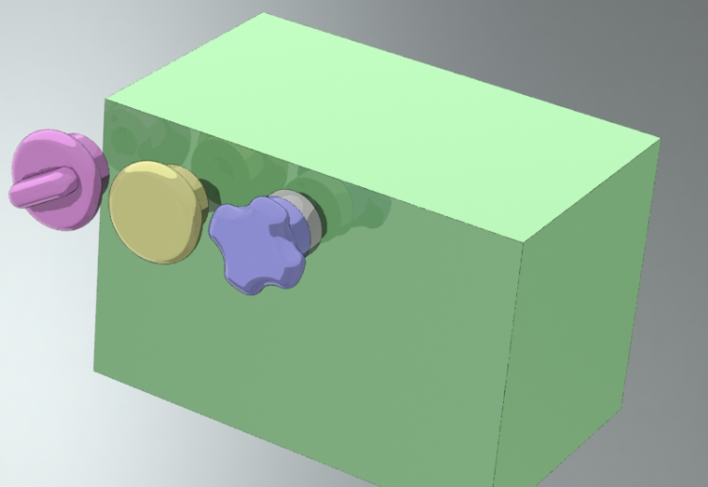 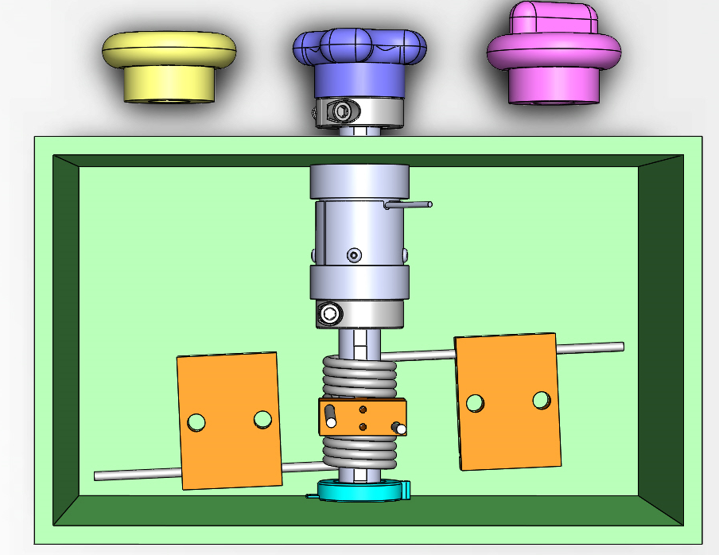

**Fig. 3:**  (A) Schematic of a twist device that consists of a rigid rod, with bearings at the two ends, constrained to rotate using two springs. The twist device is actuated with a handle. The rotation of the rod is measured by a potentiometer. The design allows a removable load cell to be placed at the end of the rod to calibrate the torque-angular displacement characteristics of the spring, periodically. (B) An internal view of the device showing the two constraining springs and the torque sensor mount.

**Bite Strength Measurement:** Schematics of a sensorized incisal bite toy and a buccal bite toy are shown in Figs. 4, 5, and 6 respectively. Both toys consist of a soft polyethylene exterior and piezoresistive fabric layer embedded in between two conductive fabric layers. The piezoresistive fabric changes resistance as a force is applied on it. The resistance change of the piezoresistive fabric will be calibrated using known applied forces measured by a force-torque sensor. This resistance change is measured as a voltage and transmitted in real-time to a computer tablet with age appropriate audio/video/graphic interface to encourage the child to operate at a maximum. The dimensions of the incisal or buccal bite toys will be designed so that a child of appropriate age can bite with either the anterior or the posterior teeth. These toys will be scaled up to meet the age and strength level of the child.

A schematic of the real-time data acquisition and visual/audio/video interface for the measurement device is shown in Fig. 7. The voltage change recorded from the toys is fed to a microcontroller that records and streams the data in real-time. The specific strength data is then calculated from these measurements and interfaced with graphic/audio/video modules to encourage the child to perform at their maximum. The recorded data over the experiment is then post-processed to compute the strength outcomes. This modular design permits multiple independent recordings to be performed simultaneously and increases the reliability of the overall system.

 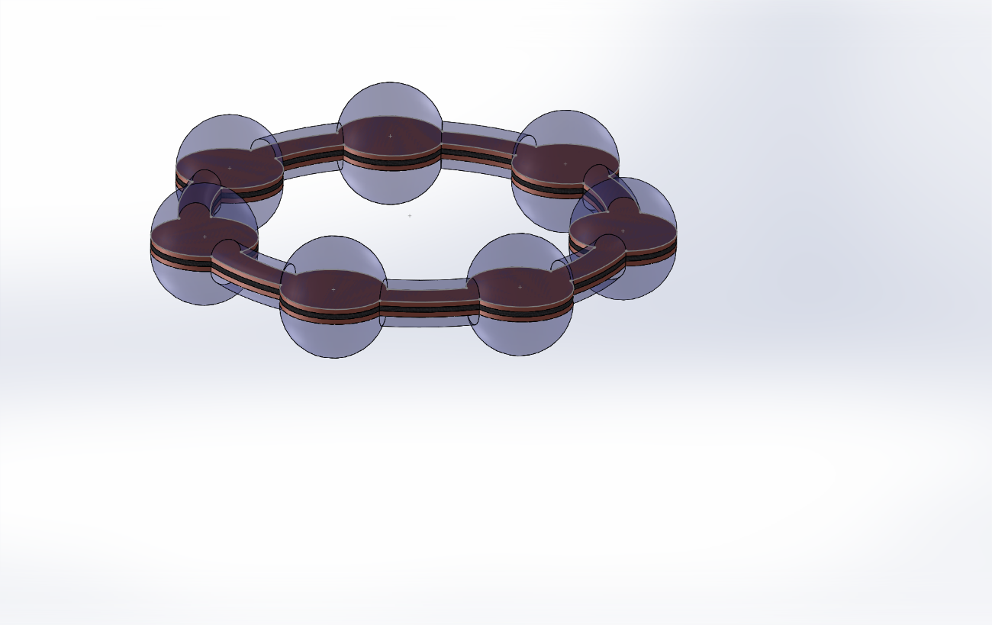 

**Fig. 5:**  (left) Picture of a child taking an incisal bite; (top right) Graphic of a sensorized incisal toy embedded with a piezoresistive fabric that changes resistance as a force is applied by anterior teeth. This resistance change is measured as a voltage and transmitted in real-time to a computer tablet with age appropriate audio/video/graphic interf ace to encourage the child to operate at a maximum; (bottom right) The pressure sensor consists of a piezoresistive fabric layered in between two conductive fabric layers. The resistance change of the piezoresistive fabric is calibrated using a known applied force read by a force-torque sensor.

 

 

**Fig. 4:**  (top left) Picture of a child taking an incisal bite; (bottom left) A soft play ring as a bite toy; (top right) Graphic of a sensorized incisal toy embedded with a piezoresistive fabric that changes resistance as a force is applied by anterior teeth. This resistance change is measured as a voltage and transmitted in real-time to a computer tablet with age appropriate audio/video/graphic interface to encourage the child to operate at a maximum; (bottom right) The pressure sensor consists of a piezoresistive fabric layered in between two conductive fabric layers. The resistance change of the piezoresistive fabric is calibrated using a known applied force read by a force-torque sensor.

A schematic of the real-time data acquisition and visual/audio/video interface for the measurement devices is shown in Fig. 7. The linear, angular displacements, or resistance changes in the devices are recorded and fed to a microcontroller that records and streams the data in real-time. The specific strength data is then calculated from these measurements and interfaced with graphic/audio/video modules to encourage the child to perform at their maximum. The recorded data over the experiment is then post-processed to compute the strength outcomes. Each sensor module includes a microcontroller that records and streams the data. This modular design permits multiple independent recordings to be performed simultaneously and increases the reliability of the overall system.



**Fig. 7:**  A schematic of the real-time data acquisition and graphic/audio/video interface for the sensor. The linear or angular displacements in the devices are recorded by potentiometers and fed to a microcontroller that records and streams the data in real-time. The specific strength data is then calculated from these measurements and interfaced with visual/audio/video modules to encourage the child to perform at their maximum. The recorded data over the experiment is then post-processed to compute the outcomes.

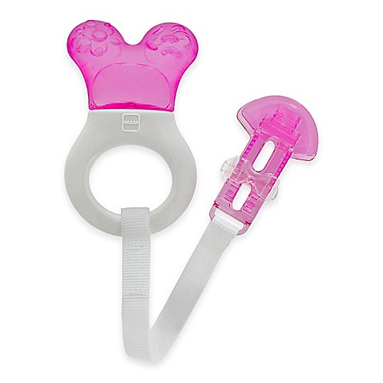 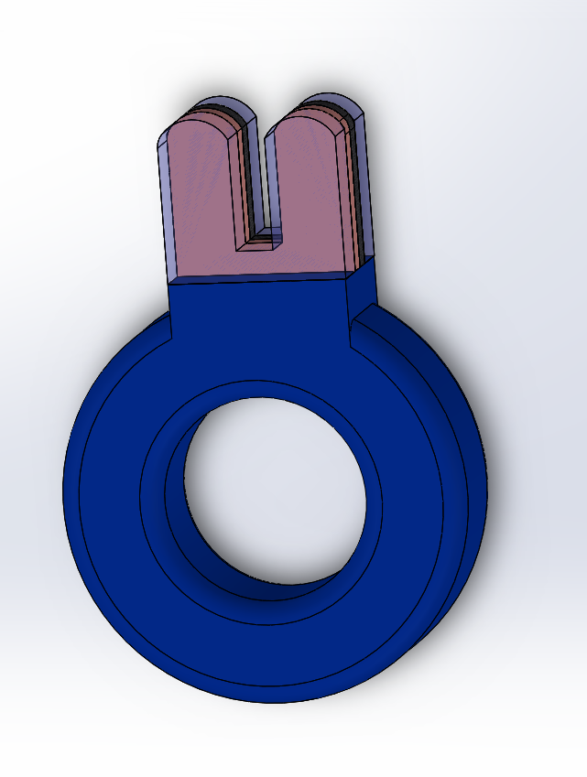 

**Fig. 6:**  (left) Picture of a child soft toy for taking a buccal bite; (middle) Graphic of a sensorized buccal toy embedded with a piezoresistive fabric that changes resistance as a force is applied by posterior teeth; (right) The pressure sensor consists of a piezoresistive fabric layered in between two conductive fabric layers. The resistance change of the piezoresistive fabric is calibrated using a known applied force read by a force-torque sensor. This resistance change is measured as a voltage and transmitted in real-time to a computer tablet with age appropriate audio/video/graphic interface to encourage the child to operate at a maximum.